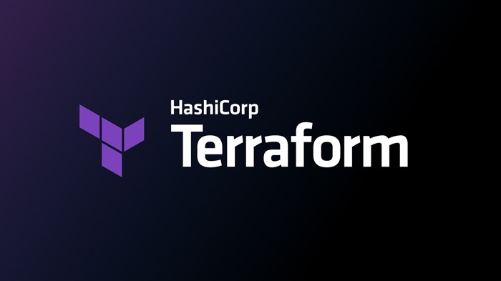
TERRAFORM 01
Title:
Install Terraform on your PC
Implementation:
Navigate to Official Terraform website and select the type of operating system and download the package
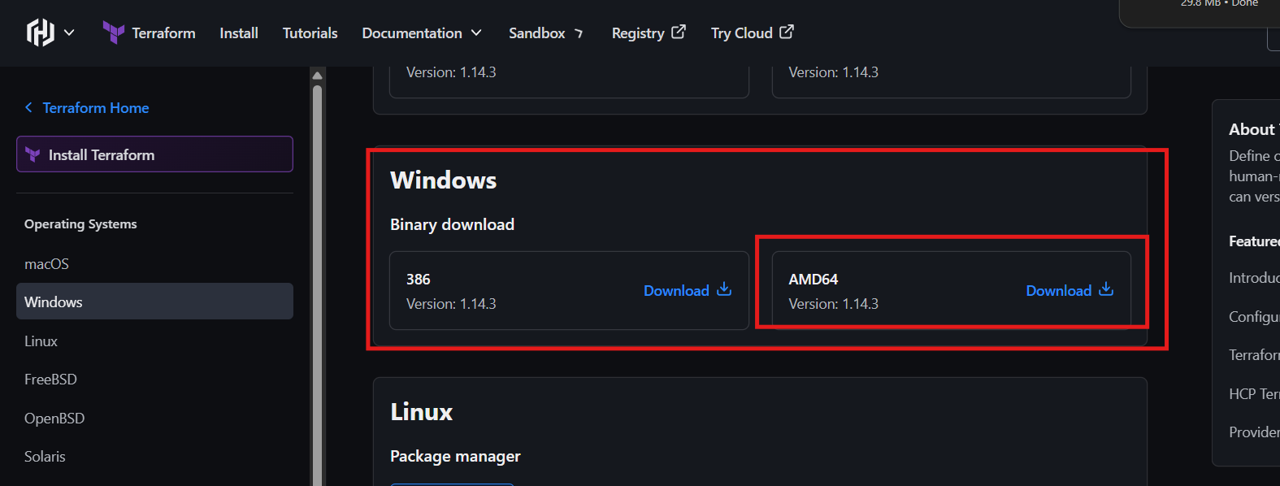

After downloading the package then navigate to downloads folder and extract the package.
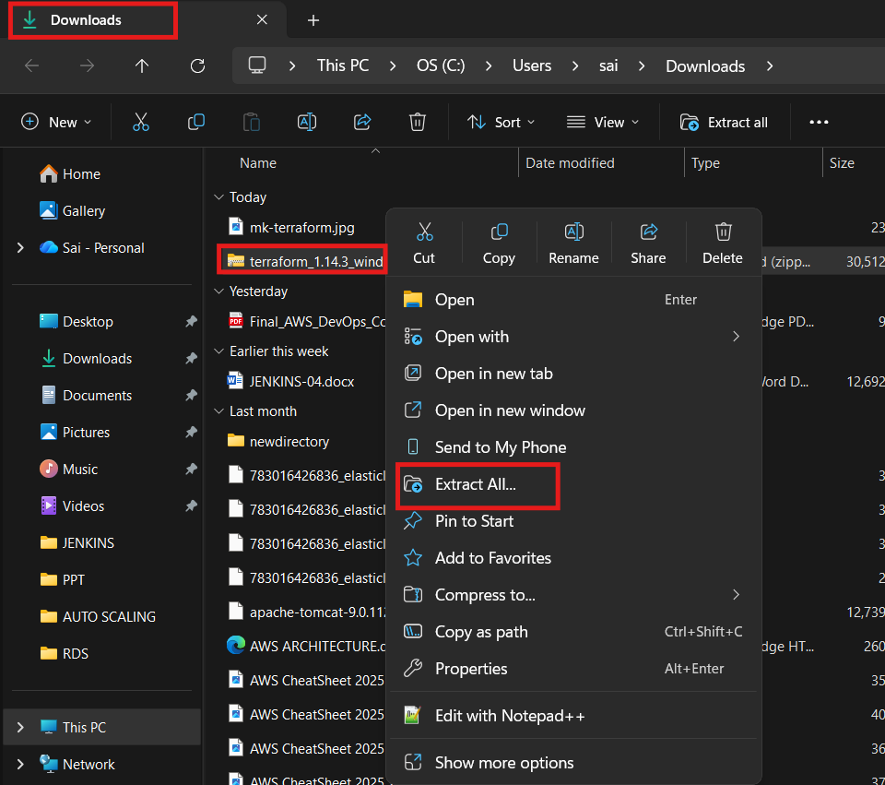

Navigate to settings env variables and add the path of terraform ,, initially create a directory naming with terraform in c folder and paste the terraform.exe file into it and select the path
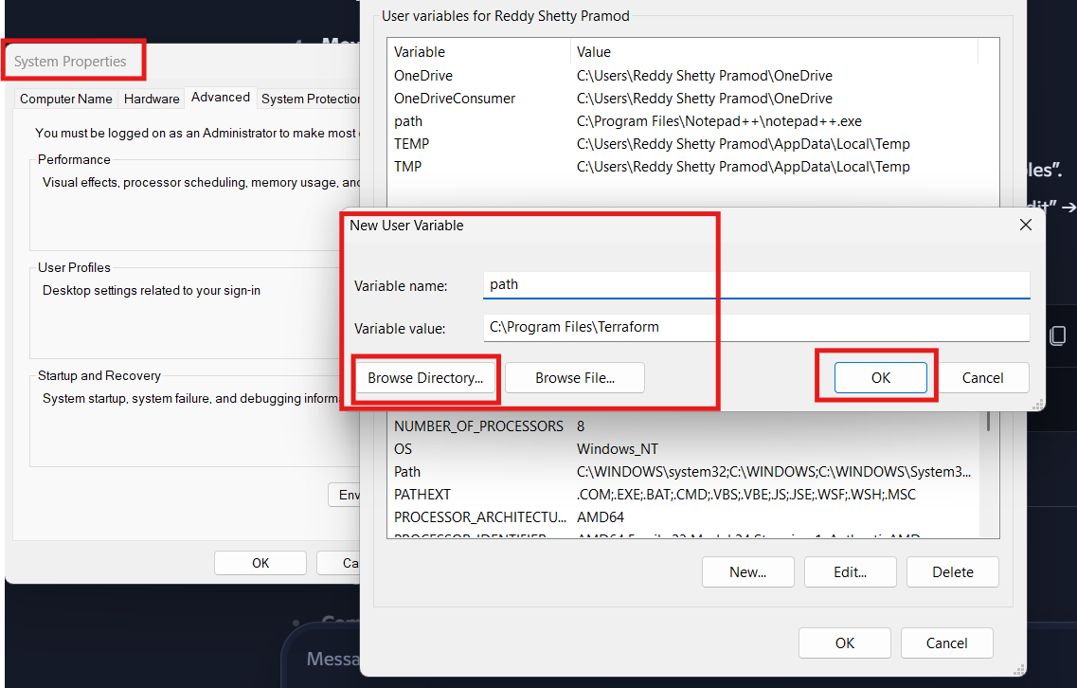
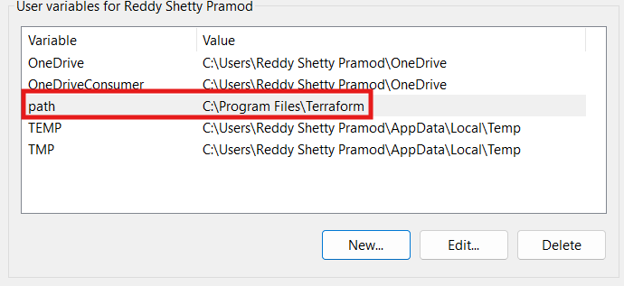

Add the path in both and save it by clicking on ok>ok>ok
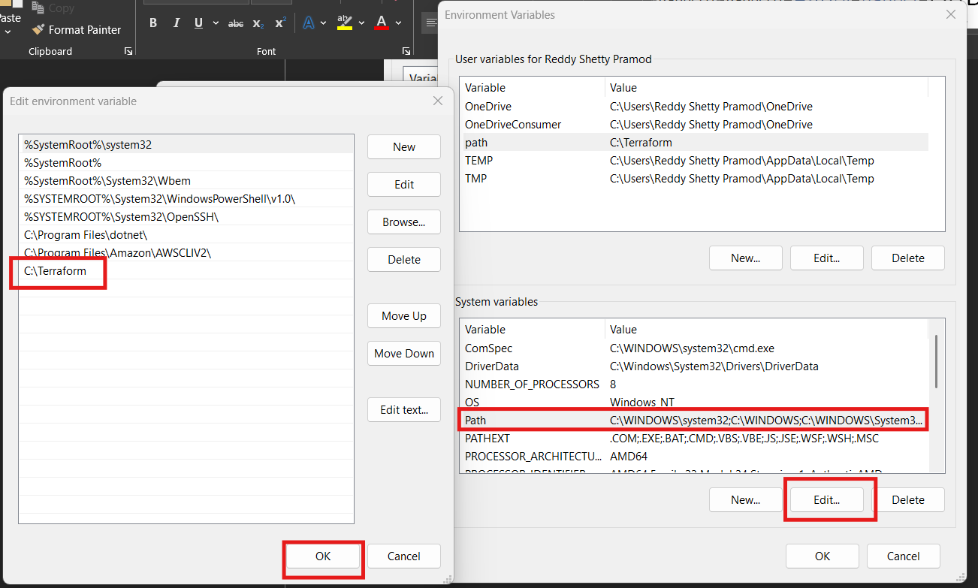
After that check in git bash or poweshell using command terraform -version then you can see the version of terraform
Note:: if you are not able to find the version unable to execute the command then it could be fault or wrong in PATH so correct that
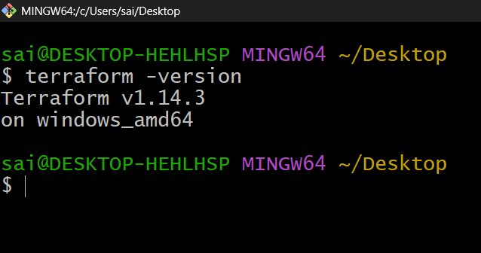
Conclusion::
Successfully installed terraform in windows.

Title:
Execute all the templates shown in video.
- Terraform Init Terraform Plan Terraform Apply Terraform Provider.
- terraform init → Initializes a working directory, downloads providers, and sets up the backend.
- terraform plan → Previews the changes Terraform will make to your infrastructure.
- terraform apply → Executes the plan and actually provisions or updates resources.
- Terraform Provider → A plugin that lets Terraform interact with a specific platform (e.g., AWS, Azure, GCP).
Implementation:
Install the extension on Visual code VI
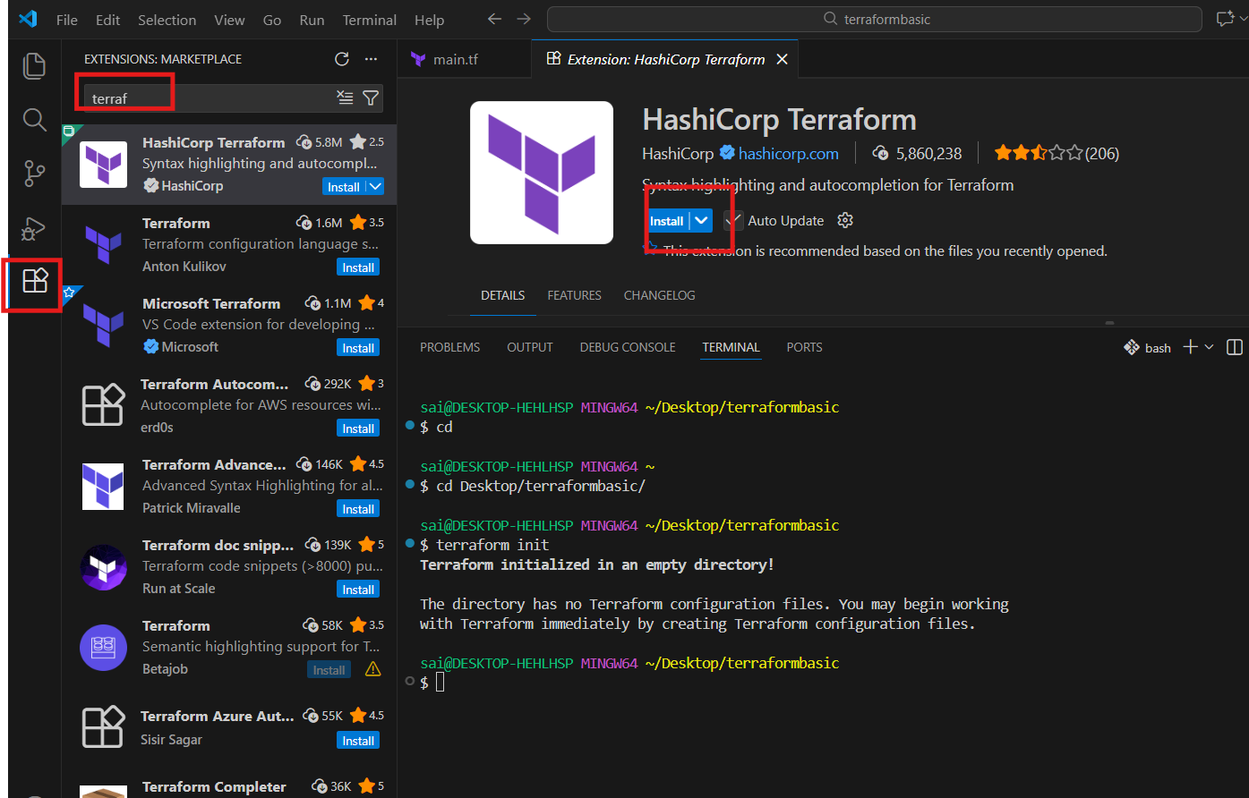

After that create a directory and create a file called main.tf and open vi and enter data
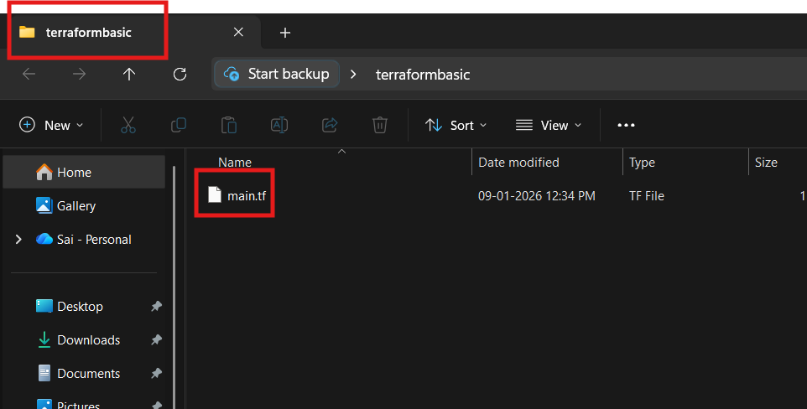
Create a file called local.tf the configuration file to create a file in local
resource --> Block name
local -->provider
file -->resource type (What needs to be created)
pet --> it is a logical name to identify by terraform and can be named anything.
********************************************************
Example syntax
resource "local_file" "pet" {
filename = "/root/pets.txt"
content = "we love pets!"
}
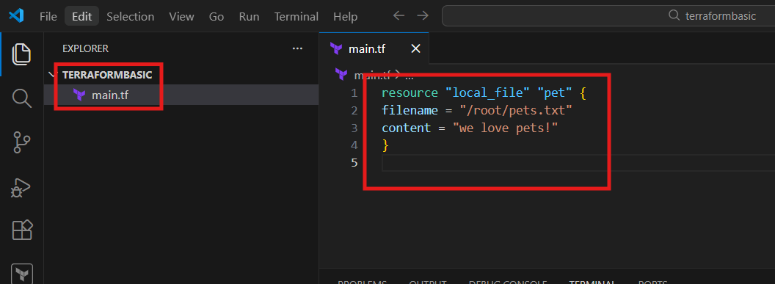
After inserting the data the file looks with terraform logo
And perform terraform init it will download the necessary dependencies
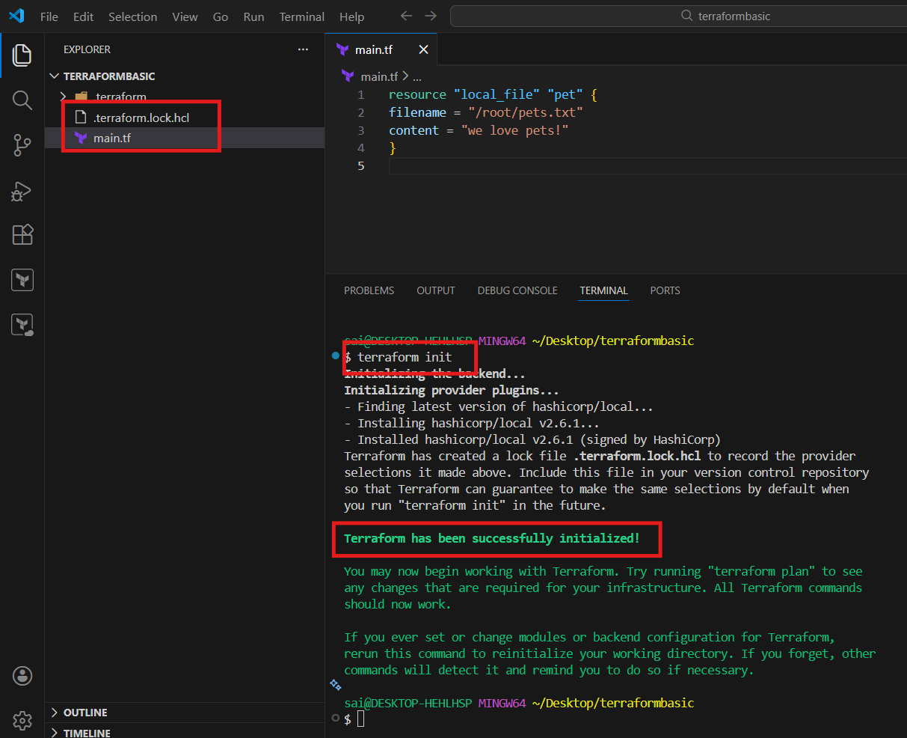

After that execute terraform plan it will show you changes or actions after executing
It will show the exact actions in file
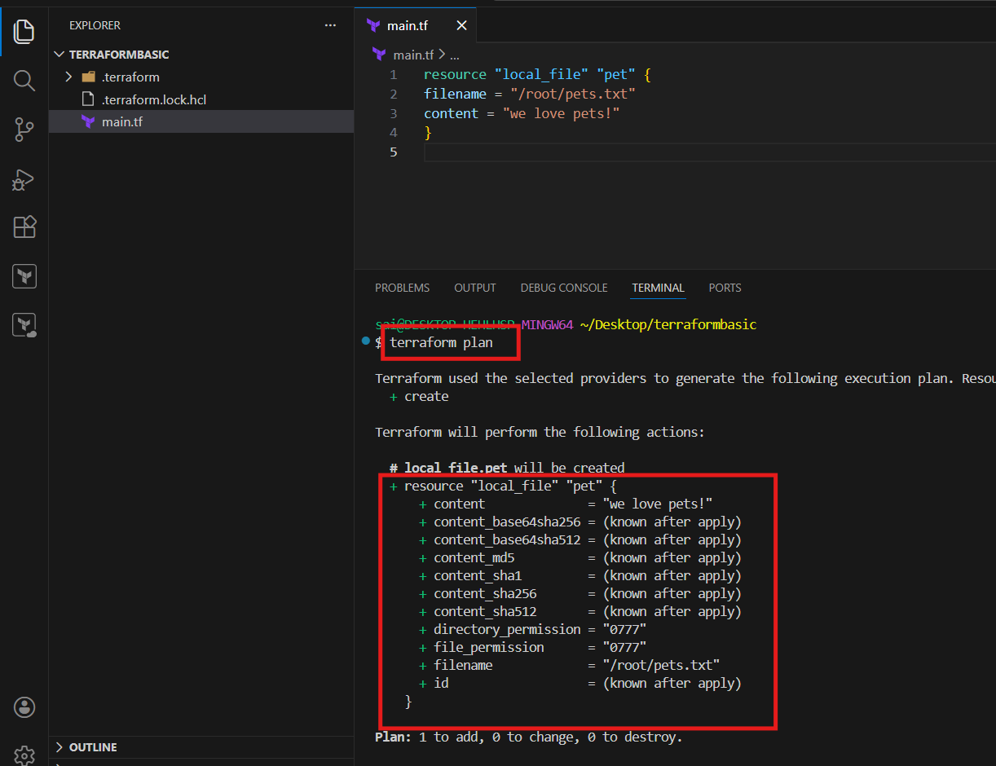

If the plan is okay then perform apply then it will ask you a confirmation and applies the changes
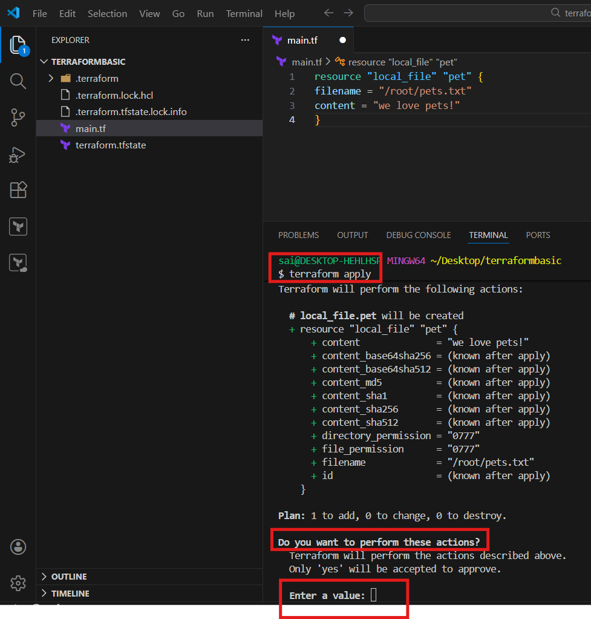

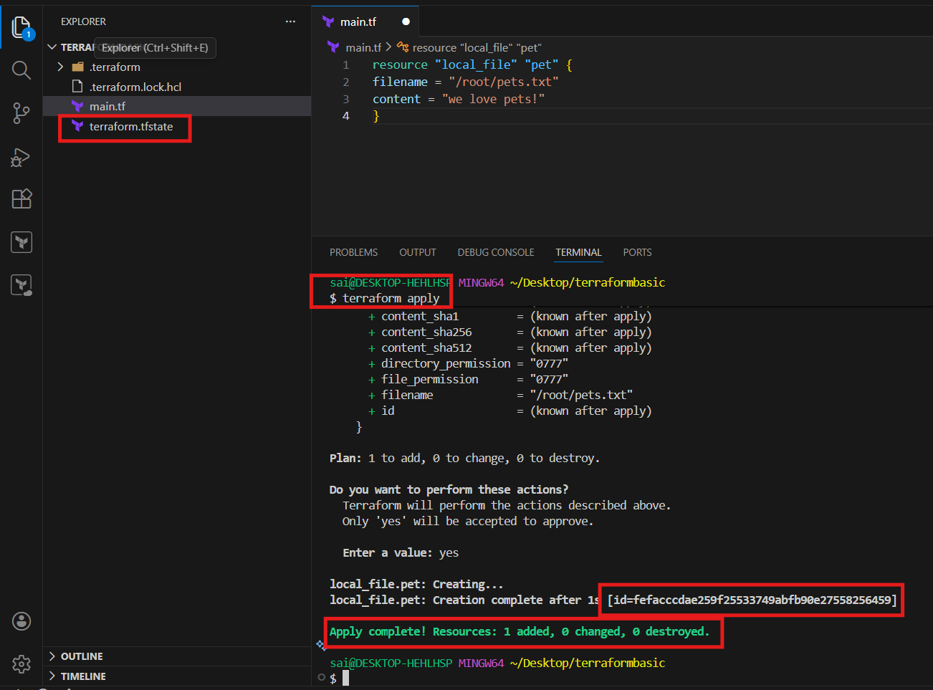
After that changed the file and perform all the actions and will see the differences
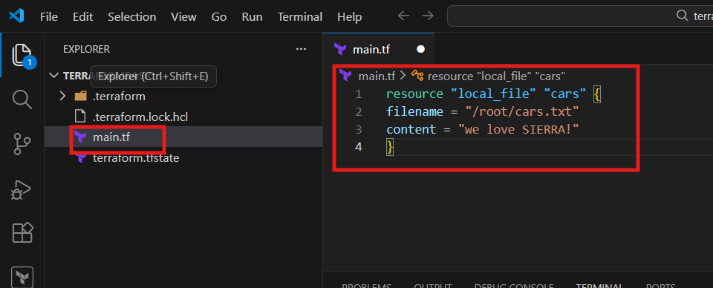
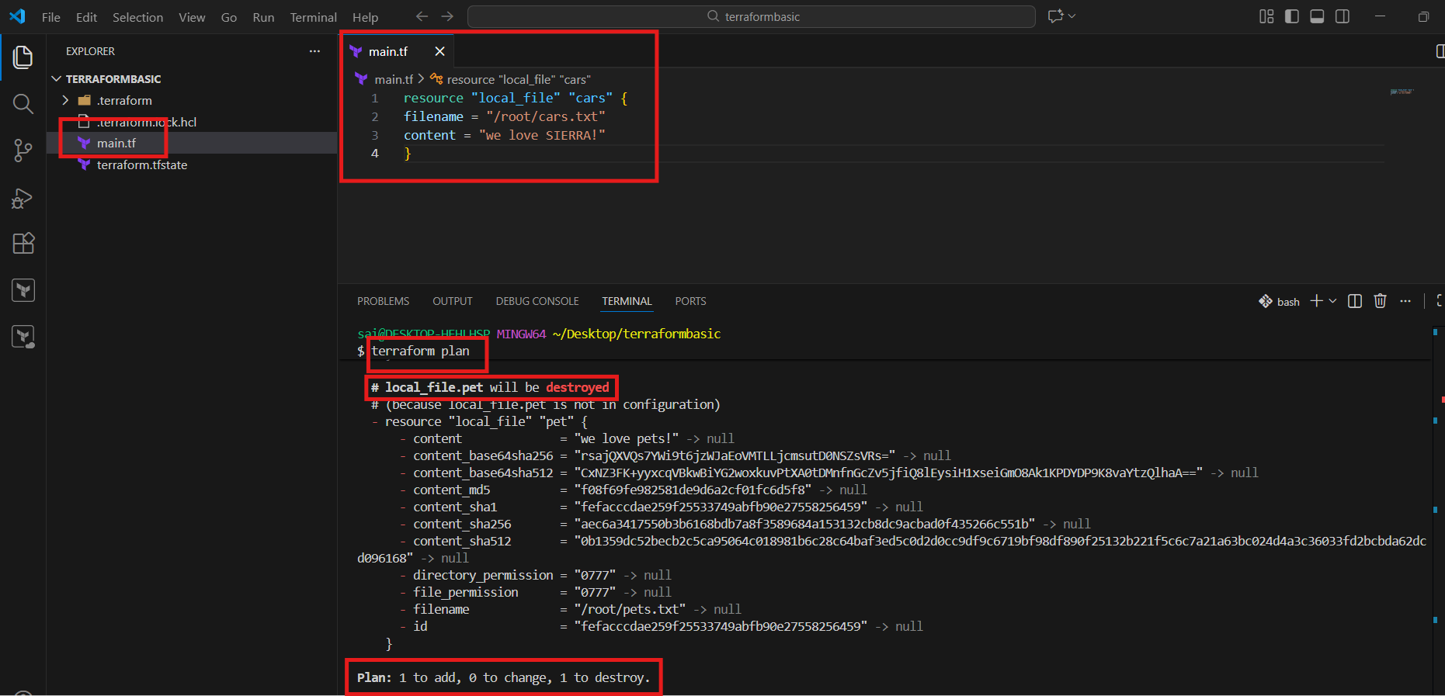
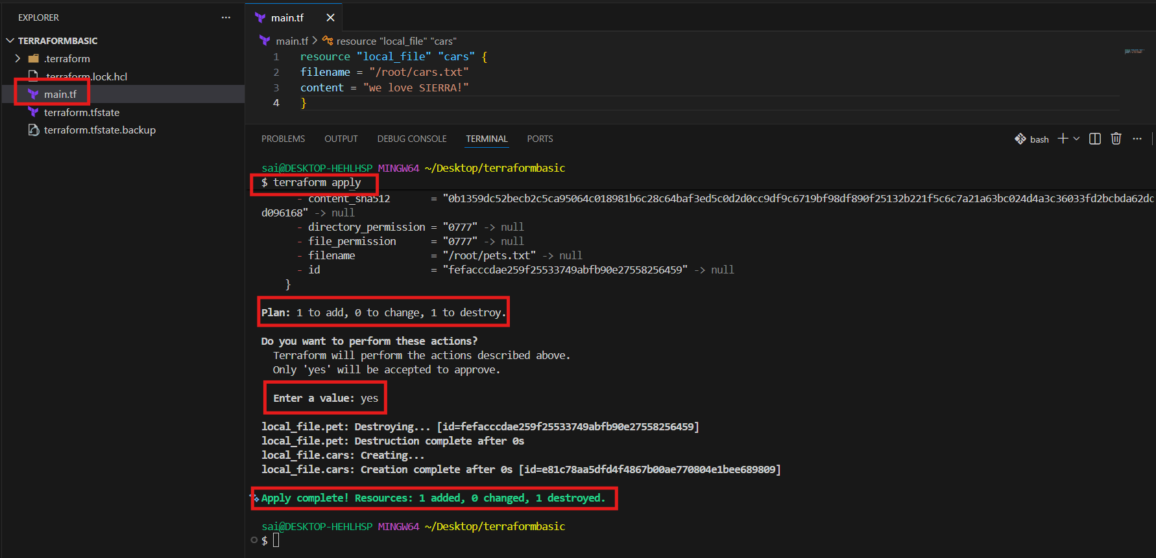
After all changes then executed the command terraform show to display the contents and info of file
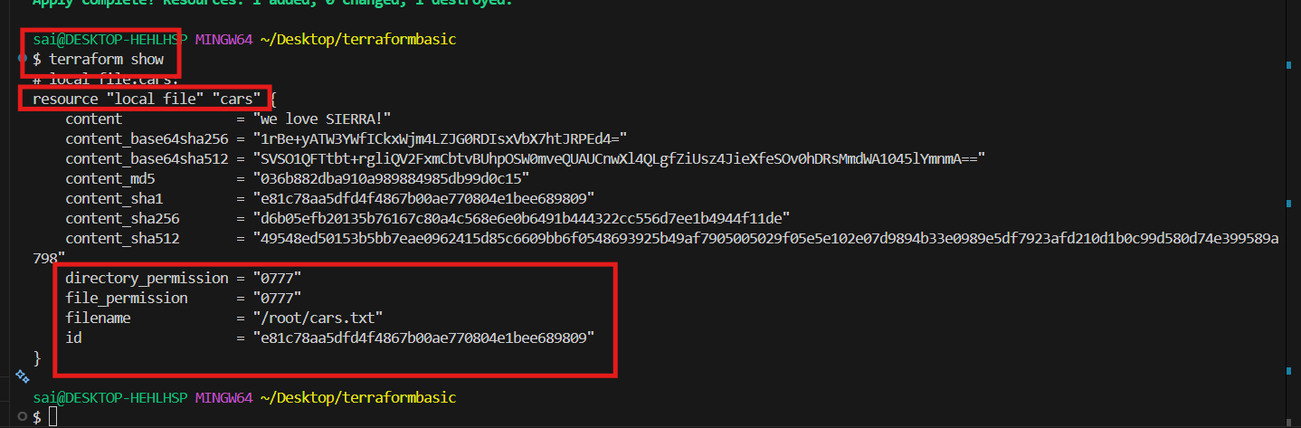

TERRAFORM PROVIDER::
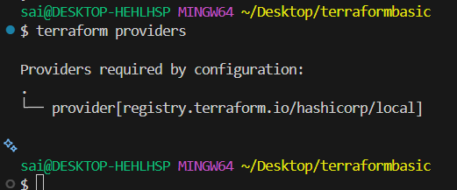
To get the formal or reference syntax of terraform then navigate to website and check in registry
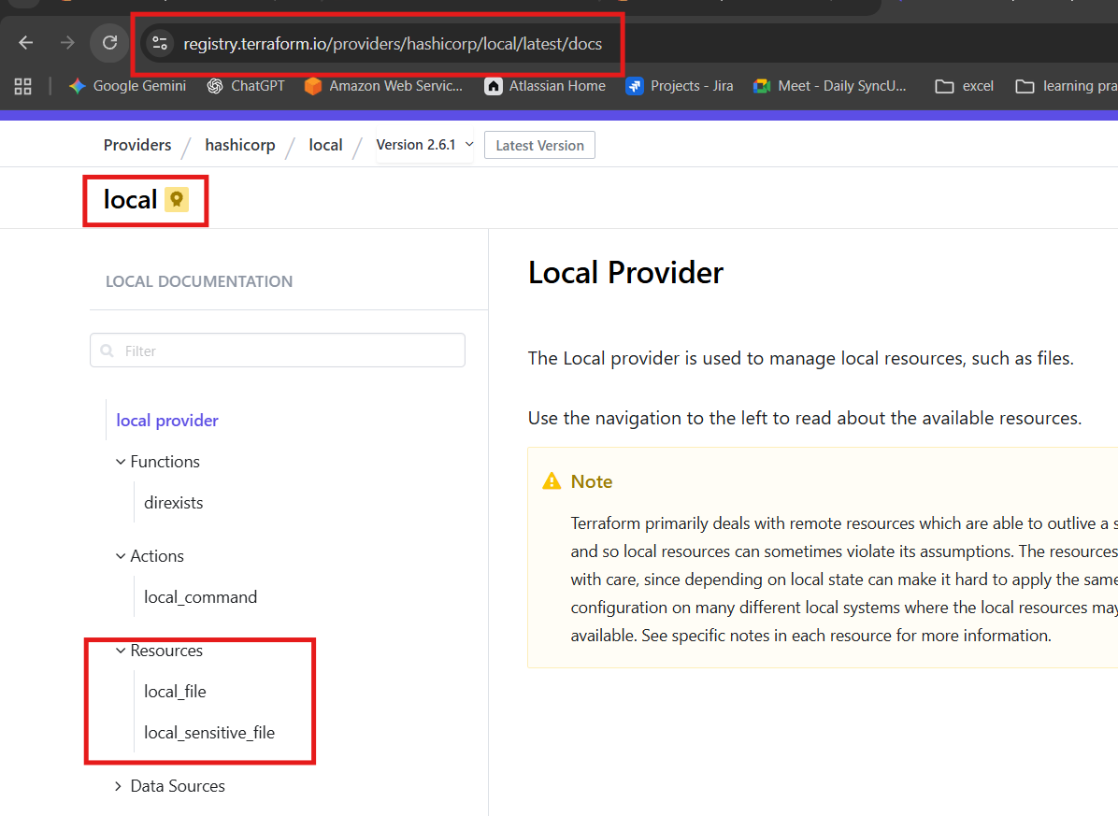
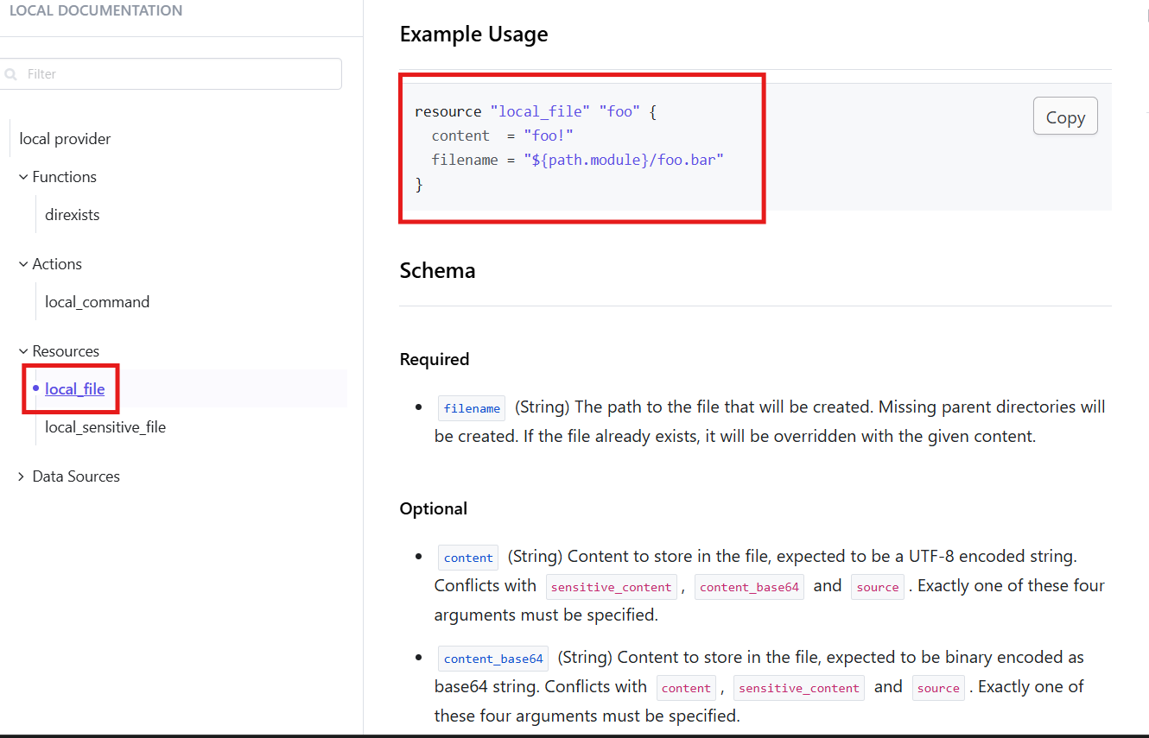
After that again changed the main.tf file and check the differences
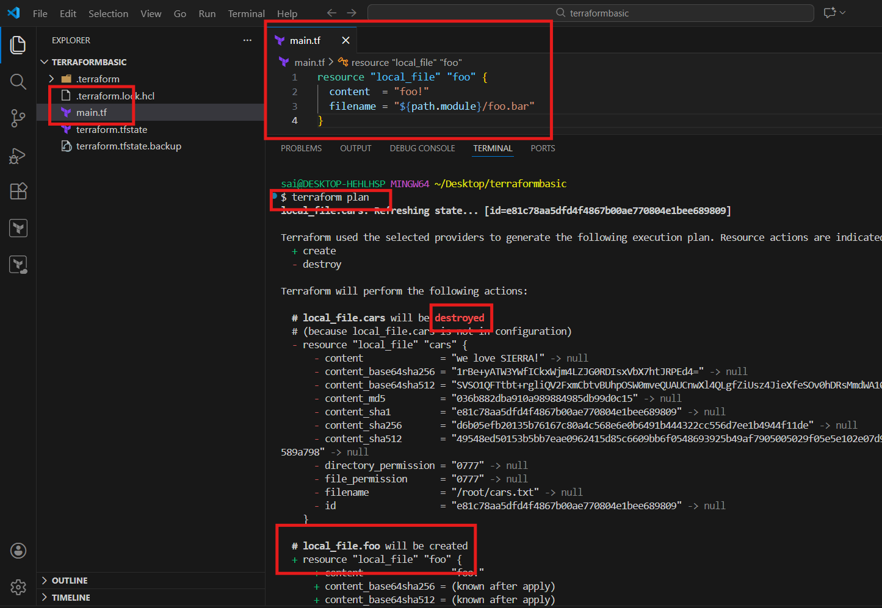
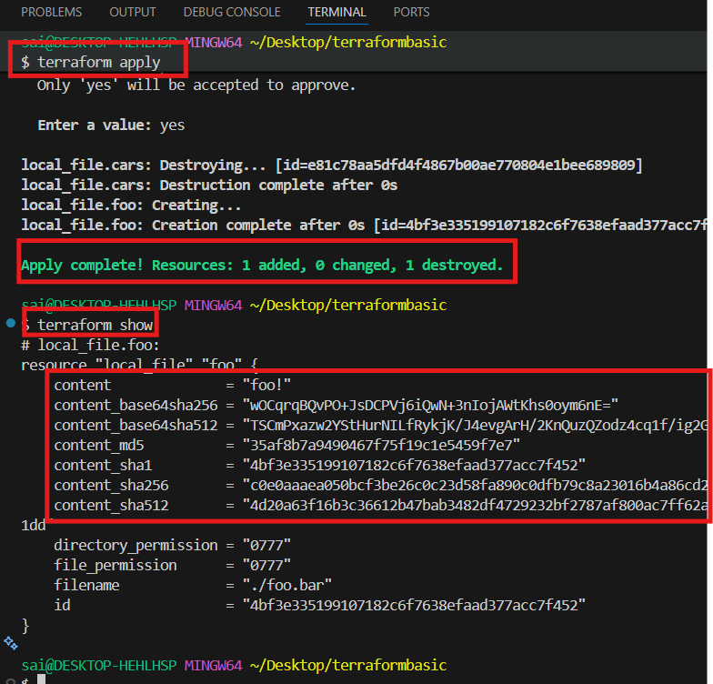

Terraform destroy command
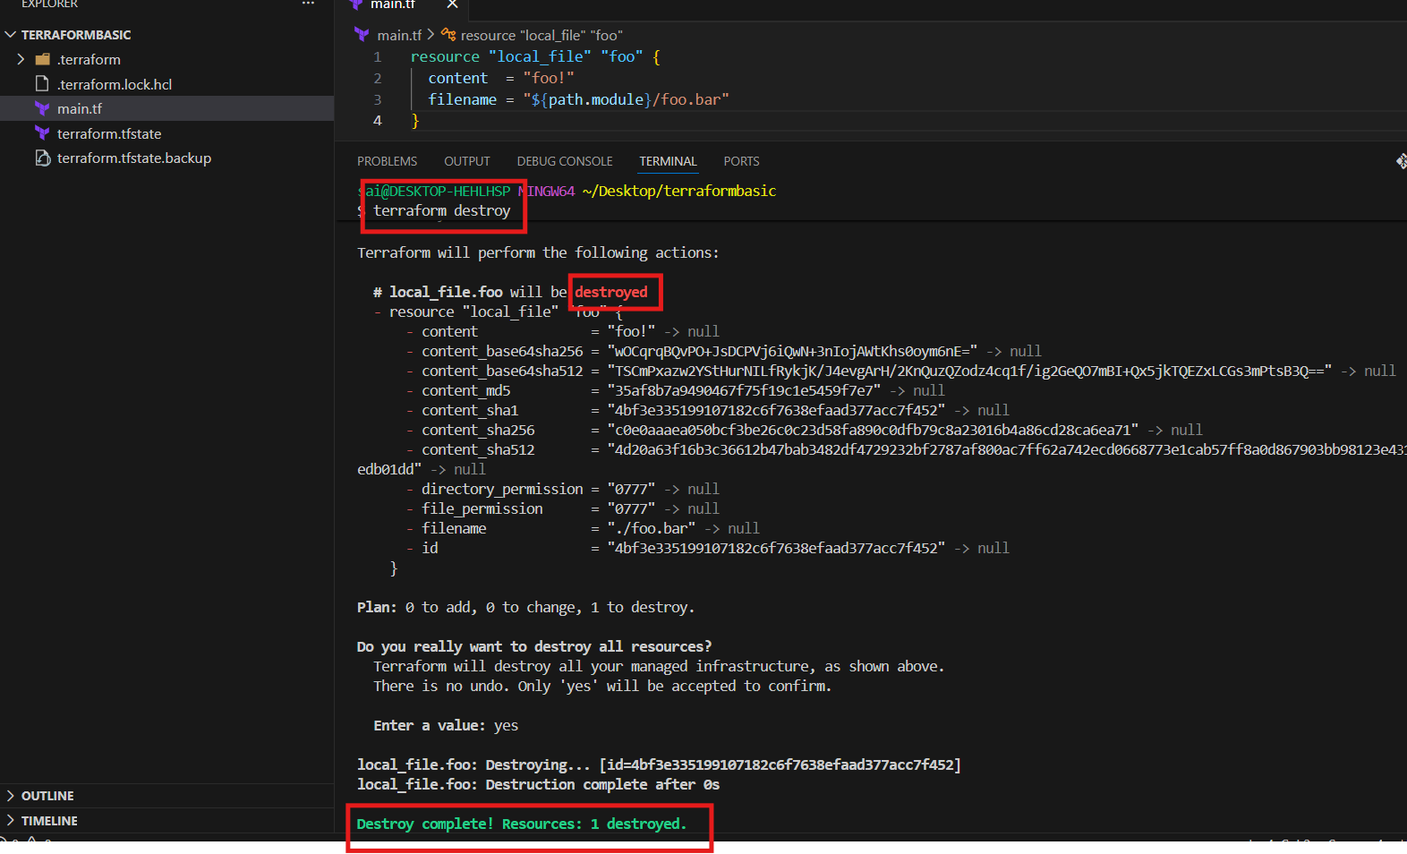
Conclusion:
Performed all the basic commands in terraform

Title:
- Integrate a sample Terraform template in Jenkins.
Implementation:
Launch the Jenkins server
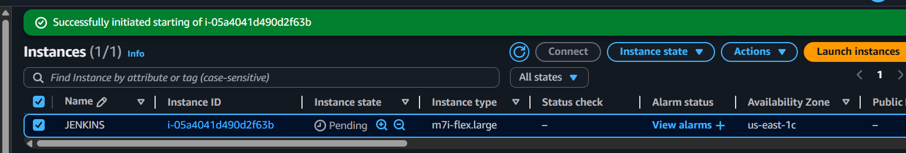
Start the server
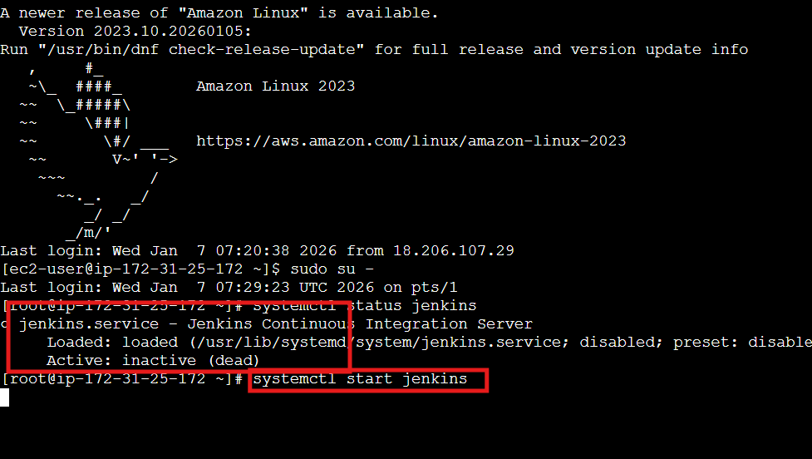
In the Jenkins install the plugin
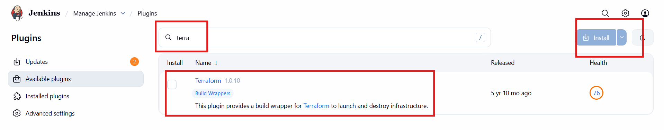
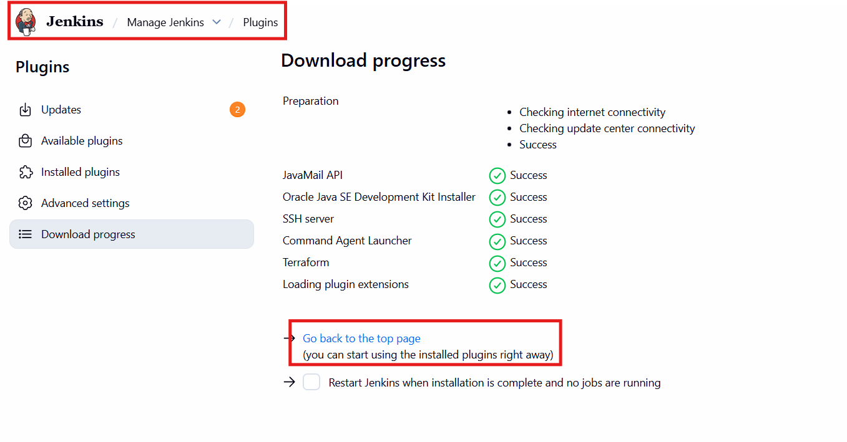
For cli level install terraform from terraform official link
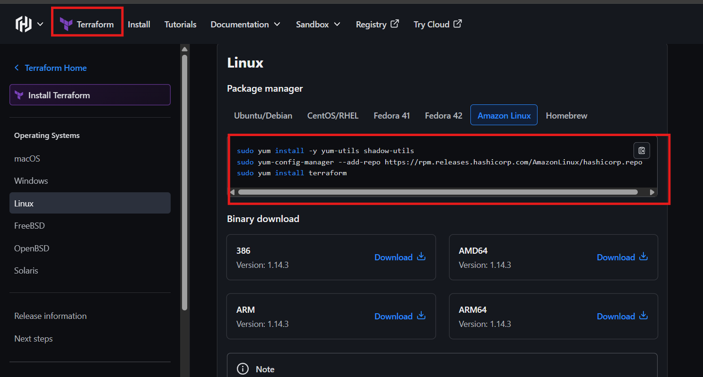
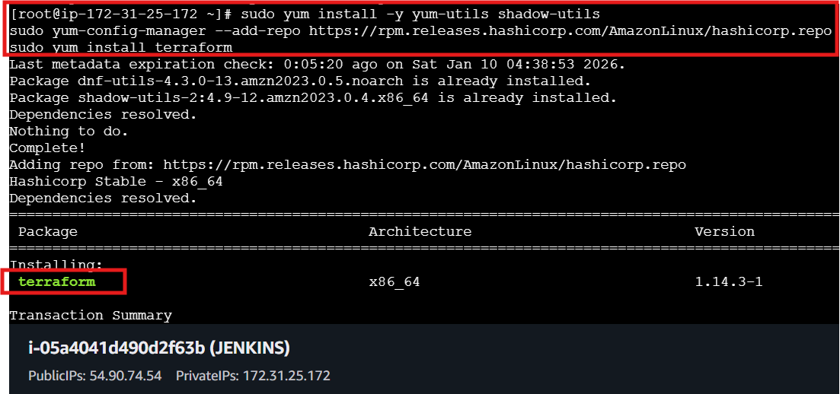
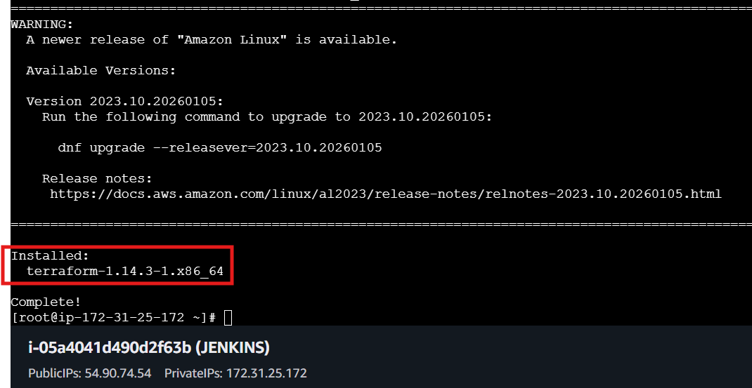

In manage Jenkins add the terraform in TOOLS
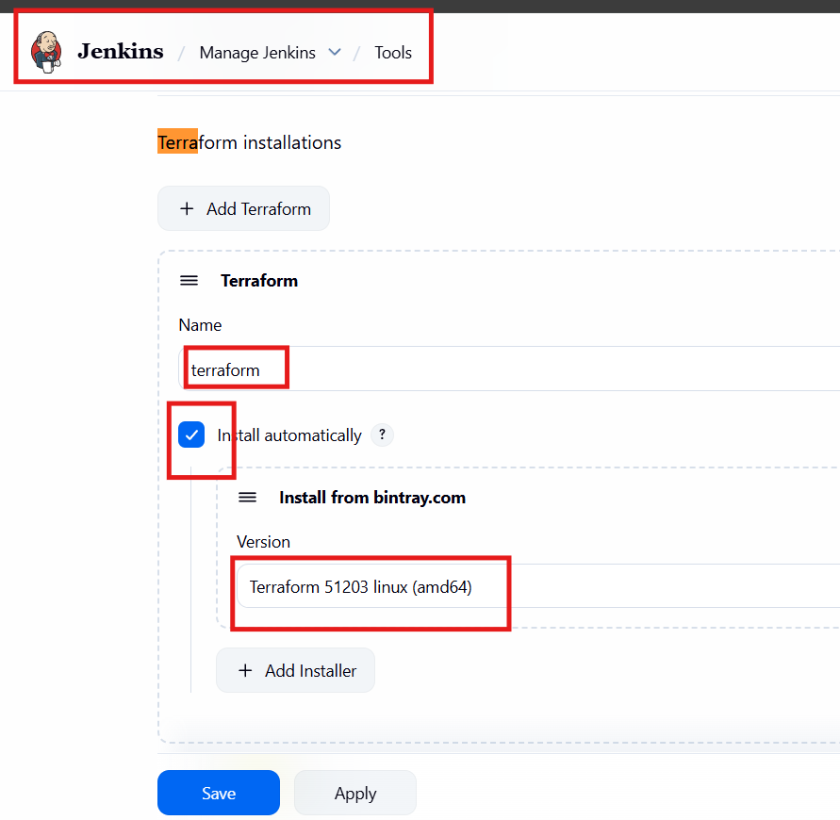

Create a pipeline job in Jenkins and build the code
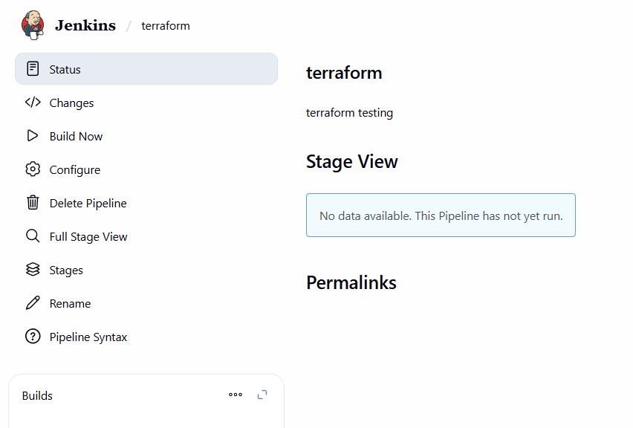
The code was succeed
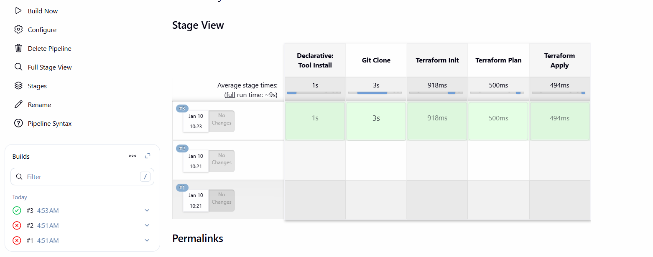

The pipeline I used
pipeline {
agent any
tools {
terraform 'terraform'
}
stages {
stage('Git Clone') {
steps {
git branch: 'main',
url: 'https://github.com/krishnav7090/terraform-jenkins.git'
}
}
stage('Terraform Init') {
steps {
sh 'terraform init'
}
}
stage('Terraform Plan') {
steps {
sh 'terraform plan'
}
}
stage('Terraform Apply') {
steps {
sh 'terraform apply -auto-approve'
}
}
}
}

